10/17/2019
Country Report: Optimal Industry Development Strategy for the United States

Heyang Huang, Soulaymane Kachani, Lun Li, Jiayu Zhao Economic Complexity lab
Columbia University
Optimal Industry Development Strategy
for the United States

0. Executive Summary

In this report, we aim to uncover the economic path the United States went through during the period from 2009 to 2014. Specifically, we dive into the topic through a macroeconomic overview of the United States from the perspective of Gross Domestic Product (GDP) and Economic Complexity Index (ECI), which reflect countries’ production capability and production structure, respectively. We find that during the period of our interest, the United States demonstrated a moderate level of economic growth with an annual GDP growth rate of 3.9%, concurrent with a decrease in economic complexity as compared with other major developed economies.

The lack of progress during the period, we believe, can be partially explained through analysis of the economic and product complexity structure of the United States on the industry group level. The product classification system we adopt allows us to measure the realized industry development for various industry groups and to observe that the United States consistently relied on developing Services and Utilities, food, Textiles and clothing industries during the period, while its developed counterparts and emerging economies around the globe have adopted much more complex and progressive paths.

Based on our analysis of the opportunity gain and a sensitivity analysis of major industry groups, the United States can further its gains by prioritizing Machinery and Construction, transportation, and those related to High-complexity Products industry groups. We further note that the United States has a slightly mismatched development strategy that indicates a moderate level of structural optimality on the complexity level, having an adjusted R-square of around 28.7%. Since a significant positive correlation exists between five-year GDP growth and the structural optimality index of an economy as we define and calculate, the United States indeed has a suboptimal growth experience as compared with fast-growing economies both on a regional scale and on a global scale, and has the potential to further its economic gains through industrial structure optimization as suggested in the paper.

1. Report Overview

In this report, we aim to uncover the economic path the United States went through during the period from 2009 to 2014. Specifically, we dive into the topic through a macroeconomic overview of U.S. from the perspective of Gross Domestic Product (GDP) and Economic Complexity Index (ECI), which reflect countries’ production capability and production structure, respectively. We then analyze the industrial framework and changes of the United States during the period based on quantitative measures such as Product Complexity Index (PCI) and Product Family Complexity Index (PfCI), followed by a detailed analysis of how such changes have matched with development strategies as quantitatively measured by opportunity gains on an industry-level. We conclude our report with macro-level results and predictions of the United States, as deduced from regression models we have established on a global scale, which take into account countries’ stances in their product space.

2. Macroeconomic Results

2.1 GDP Ranking and Changes
As the largest economy in the world by GDP, the United States has a GDP of 14.4 trillion USD in 2009 and 17.4 trillion USD in 2014, exhibiting an extraordinary level of economic output. Figure 1 illustrates the time-series GDP results for world’s leading economies from 1996-2016, and the United States ranks among its counterparts as the absolute winner. Except for the period of financial crisis from 2008 to 2009, the United States has exhibited a rather consistent level of economic growth, with an annual GDP growth rate of 3.9% from 2009 to 2014. This rate is slightly below the annual growth rate of the group of leading economies in the world, which have a geometric average growth rate of 5.1% and an arithmetic average growth rates of 5.2%. However, the annual growth rate of 3.9% is in sharp contrast to an annual growth rate of 15.5% for China, one of the United States’ major competitors in the market. The steady rate of growth in the United States, we believe, can be reflected through consistent ECI and PCI, and can be further explained by a moderate set of production strategies the United States adopted during the period, which we will expand at the later stage of the report.

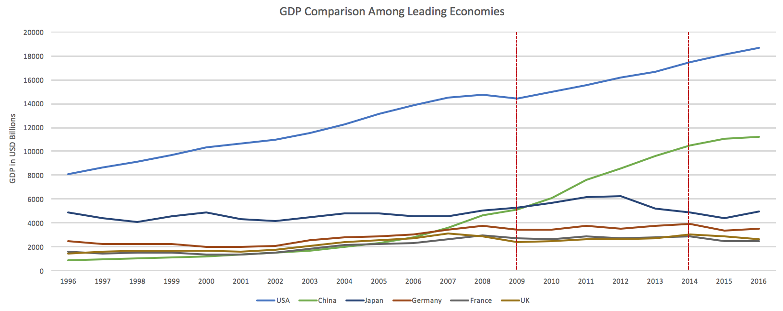

Figure 1: GDP Comparison Among Leading Economies

2.2 ECI Ranking and Changes
The Economic Complexity Index (ECI), as defined by Ricardo Hausmann and Cesar Hidalgo in 2009 to explain the knowledge accumulated in a country's population, exhibits similar pattern for the United States. As illustrated in Figure 2 below, the United States exhibits a mild decrease in terms of its production capability from 2009 to 2014, which is true for most of the developed economies. This is in direct contrast to countries such as China, which demonstrates overwhelming advantage over the United States in terms of both ECI and GDP growth during the period.

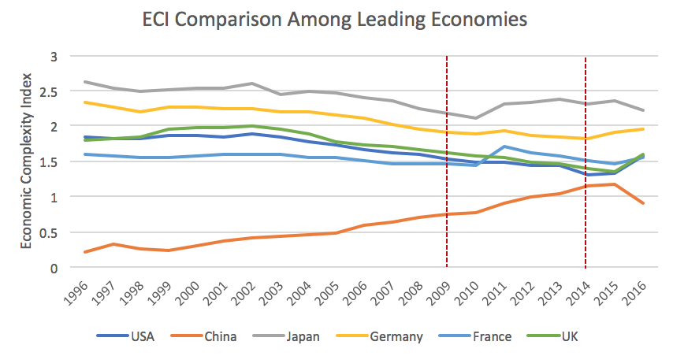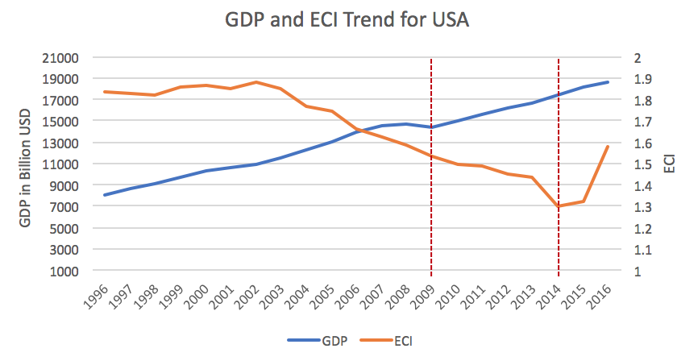

Figure 2: ECI Comparison Figure 3: GDP Growth and ECI (U.S.)

Figure 3 offers a further comparison of GDP Growth and ECI over the entire time span from 1996 to 2016 for U.S.. The stagnancy in GDP growth during the period from 2009 to 2014 is accompanied by a significant decrease in ECI. The results show that the economic growth experienced by U.S. during the period from 2009 to 2014, though stable, is not very consistent with the predictions by ECI and U.S. had not yet effectively developed a competitive product space that helps to accumulate complicated knowledge and technology. In order to provide a more concrete answer to why this has happened, we will dive into an analysis of U.S.’s production structure and its product space designs in the next few chapters.

3. Production Analysis

3.1 Product Categorization
Our main data source in this research is the UN Comtrade Website (https://comtrade.un.org), which provides us with valuable information on countries’ export values on an annual basis, including highly specific export data for more than 5000 categories of products. In order to have a holistic vision of the product space of a country, however, a level of categorization is required. Product in our data source are labelled from 010000-999999, with the first two-digits representing a general category to which the product belongs. Based on the 99 categories as extracted from the label, we further group the products into 18 most widely-accepted industries, as summarized in Table 1.

Note that the High-complexity Products industry group is not a distinct industry but rather an aggregated industry that encompasses the most complicated products from the most technologically-advanced industries (as measured by PCI). This industry serves as an indicator for us to quantitatively evaluate how well a country has performed in developing cutting-edge technologies and closing its technical gap with advanced economies, which has become a topic of wide concern today. Indeed, when we rank the 18 categories based on PfCI (an equivalent concept of PCI as calculated based on the 18 categorized product groups), High-complexity Products industry has the highest PfCI among all industry groups.

Category | Description
Animals and By-products | All kinds of meat, livestock and related by-products
Vegetables, Fruits and Plants | All kinds of plants, edible vegetables and fruits
Food and Preparations | Edible preparations, raw cooking materials and appliances
Clothing and Accessories | All kinds of fabrics, filament, clothing and accessories
Textiles | All kinds of textile articles and related products
Wood Products | Book, paper and other elementary products related to wood
Metals | Mining of all sorts of raw Metals
Refined and Processed Stones | Refined or processed stone products such as pearl and ceramics
Energy Drilling and Mining | Mining industry for energy, minerals, stone materials, etc.
Daily Instruments | Basic daily instruments such as sport requisites, timing and measuring tools
Raw Manufacturing | Basic products made from plastic, rubber, leather, etc.
Chemical Manufacturing | Advanced chemical products and pharmaceutical products
Chemicals | Raw chemical materials and by-products
Machinery and Construction | Machinery and mechanical appliances, including electrical equipment
Transportation | Vehicles and locomotives including aircraft, ship, railway, etc.
Weapons | Explosives, arms and ammunition
Services and Utilities | Financial, business, legal, communication, travel Services and Utilities, etc.
High-complexity Products | Agglomeration of advanced products with highest PCIs

Table 1: Categorization of Products

We further observe a strong positive correlation between the GDP and the export of High-complexity Products. As shown by Figure 4 below, a high adjusted R-square of 67.6% exists between GDP and High-complexity Products exports, indicating that more successful economics, as measure by GDP, tend to be those that are capable of producing and exporting High-complexity Products as we define them.

Statistics | Value
Multiple R | 0.824
R-Square | 0.679
Adjusted R² | 0.676
Variable | Value
Coefficient | 12.20
t-stat | 15.61
P-value | 0(***)


Figure 4: Regression of GDP and High-complexity Products Exports

3.2 Realized Industry Development

Based on the product categorization aforementioned, we aim to capture U.S.’s realized industry production strategy between 2009 and 2014 on a complexity level. In Hausmann and Hidalgo (2009), distance is defined to be a measure of how far a country is from a certain product not in its product space. We extend this concept to all product groups and quantify how technically equipped a country is to develop the corresponding product groups. In other words, the shorter the distance between a country and a product group, the more capable a country is in developing products within that group. Defining this net distance change as the Realized Industry Development (RID), our export data allow us to calculate and compare RID of U.S. and the 18 product groups in 2009 and 2014 through subtraction, where a positive RID indicates a shortening of the distance (i.e., advancement of the industry), and a negative RID indicates the reverse. As ranked in Table 2, during the period from 2009 to 2014, U.S. has focused mostly on products of high complexity and those requiring advanced skills, including Services and Utilities and chemical manufacturing.

Category | RID | Category | RID
1. Services and Utilities | 0.242 | 2. Chemical Manufacturing | 0.229
3. Food and Preparations | 0.197 | 4. Textiles | 0.196
5. Clothing and Accessories | 0.195 | 6. Animals and By-products | 0.192
7. Metals | 0.192 | 8. Transportation | 0.191
9. High-complexity Products | 0.190 | 10. Machinery and Construction | 0.184
11. Weapons | 0.183 | 12. Raw Manufacturing | 0.181
13. Energy Drilling and Mining | 0.171 | 14. Refined and Processed Stones | 0.161
15. Chemicals | 0.144 | 16. Wood Products | 0.118
17. Daily Instruments | 0.105 | 18. Vegetables, Fruits and Plants | 0.086

Table 2: Realized Industry Development (RID) of U.S.

3.3 Regional and Global Comparison
Table 3 and 4 below summarize how the production strategy adopted by U.S. compares with its Western counterparts and a selected group of emerging economies in the world, as measured in RID. It can be directly observed that U.S. focused almost exclusively on products with high complexity level, when compared against its Western counterparts such as France, which still gave a considerable level of attention to intermediate-level product groups such as raw manufacturing and Refined and Processed Stones.

Ranking | U.S. | France | Germany
1 | Services and Utilities | Raw Manufacturing | Chemicals
2 | Chemical Manufacturing | Energy Drilling and Mining | Services and Utilities
3 | Food and Preparations | Refined and Processed Stones | High-complexity Products
4 | Textiles | Chemical Manufacturing | Transportation
5 | Clothing and Accessories | Chemicals | Food and Preparations

Table 3: RID Comparison across Leading Economies

Ranking | China | South Korea | India
1 | Refined and Processed Stones | Chemicals | Daily Instruments
2 | Services and Utilities | Machinery and Construction | High-complexity Products
3 | High-complexity Products | High-complexity Products | Wood Products
4 | Machinery and Construction | Weapons | Machinery and Construction
5 | Chemicals | Refined and Processed Stones | Chemicals

Table 4: RID Comparison across Emerging Economies

Table 4 further examines U.S.’s development strategy against those of leading/emerging economies on a global scale. Reasonably, emerging economics such as China and Korea have devoted a significant amount of their efforts into intermediate-level industry groups while leading economies such as Germany are more similar to U.S. in terms of their developmental strategies. This trend holds true in general, regardless of the continent or the time period, and serves as an indicator for which phase of development a country is currently in as evaluated from their production strategy. Based on this standard, U.S. is indeed adopting an ambitious strategy that seeks development in its advanced industry groups.

4. Product Space Design

4.1 Suggested Development Vector
As aforementioned, distance gives us an idea of how far each new product is from a country’s current mix of exports. As defined in Hausmann and Hidalgo (2009), distance is “the weighted proportion of products connected to goods p that country c is not exporting, i.e., MCP=0.” Based on this definition, the distance between a country and any product that the country is currently exporting (i.e., the country is a significant exporter in the product as compared to global average) is zero. Similarly, opportunity gain quantifies the contribution of a new product in term of opening up the doors to more and more complex products. Intuitively, a product that a country is currently exporting (i.e., MCP=1) has an opportunity gain of zero. And unreasonable investment on certain product p would lead to a relative decrement in export of more profitable products, and therefore lead to a negative opportunity gain of product p. The opportunity gain is not the only estimator of a country’s level of economic development. However, among countries with comparable economics strength, those having higher ECI, or in other words, more reasonable economics structures are often in better shape.

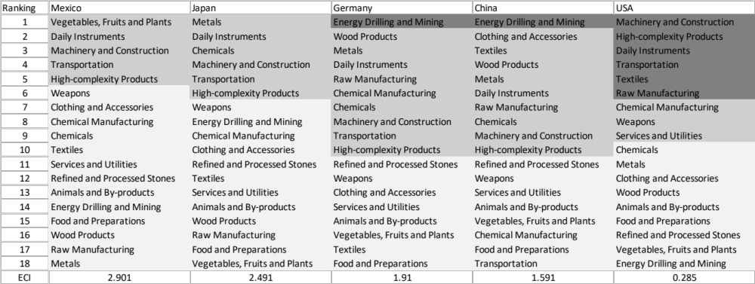

Table 5: SDV of High E_{f}CI Countries 2014

We define the ranking of opportunity gain for a country c, as the Suggested Development Vector (SDV) of c. Table 5 shows the SDV of a selected group of leading economies with outstanding economic complexity, with the industry groups ranked in decreasing order of significance. Dark grey indicates positive opportunity gain, gray indicates zero opportunity gains, and light grey indicates negative opportunity gains. The result shows that leading countries barely have any industries with positive opportunity gain. In other words, those countries are already in the most stable and efficient economic structure. Without the necessity of economic transition, those countries merely need to maintain a steady and balanced economic development. In contrast, countries listed in Table 6 have nearly half of industries with positive opportunity gain. While the economies with absolute negative E_{f}CI, such as Nigeria and Algeria, all need to develop High-complexity Products, Machinery and Construction and Daily Instrumentss, those with median E_{f}CI are facing a more complicated and diverse situation, such as Italy, Spain and U.S..

It can be concluded that U.S. is categorized to be a highly complexed country as compared with the world’s leading economies and other major economies in Europe.



Table 6: SDV of Other Typical Countries 2014

4.2 Sensitivity Analysis and Contingency Strategy
U.S. has a characteristic SDV of high-complexity economy and is embedded with massive production knowledge. U.S. should take precautions against unexpected strikes industry by industry and forecast the adverse effects. The regression of an industry with low PCI and low Opportunity Gain is less dangerous than that of cornerstone industries. High-complexity Products is such a representative of the cornerstone industries, because High-complexity Products connects to most of the profitable products that developed countries are currently specializing in. For the same token, Food and Preparations is one of the less fundamental industries for developed countries. Such intuition can be rigorously proved by the sensitivity analysis we are about to implement.

The sensitivity analysis aims to approximate the volatility of SDV subject to an instant increment or decrement of export and is mainly implemented on developed countries that have few industries with positive opportunity gains. To be more specific, sensitivity score is the least-squared slope for the linear regression between percentage change of production for
Country C and Product P and the E _{f} CI of C.

When the opportunity gain of the industry is negative, the sensitivity analysis approximates how an over-development of the industry jeopardizes the economic structure of a country. When the opportunity gain of the industry is zero, the sensitivity analysis determines whether the further development of the industry shapes the country a better economic structure, and predicts how the SDV would change accordingly. Specifically, as we reduce the export of such an industry to 25%-50% of its original value, a few other industries originally with negative opportunity gain would probably become profitable. We separate the increment and decrement of production in the sensitivity analysis, because they tend to show vast difference. The considerable profitability of a production spike doesn’t imply a shrink is always followed by a painful crisis.

We perform the sensitivity analysis of the aggregate of top ECI countries, including US, UK, Korea, Japan, South Korea, Singapore, Germany, and France, and use the result as the benchmark. The sensitivity score in 2014 and 2009 are shown in Table 7 and Table 8 respectively:

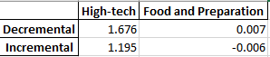

Table 7: Sensitivity Score of the Aggregate of Developed Countries 2014

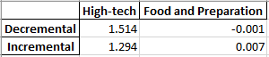

Table 8: Sensitivity Score of the Aggregate of Developed Countries 2009

In summary, High-complexity Products exerts great impacts on economics structure of top countries. Such countries are extremely vulnerable to High-complexity Products industry declines, and benefit from High-complexity Products prosperity. In contrast, ECI is not highly sensitive to shift of Food and Preparations industry.
We observe a similar pattern that the Sensitivity Score of Food and Preparations is approximately zero, while the Decremental Sensitivity Score is larger than the Increment. We can therefore make three conclusions here.
- The disturbance in Food and Preparations industry exert a trivial impact on the E_{f}CI of a country, which echoes with our intuition that Food and Preparations is of minimal significance to the structure of product space of developed countries or fast developing countries.
- The High-complexity Products industry is the cornerstone industry of most developed or fast developing countries.
- The reward of an increase of High-complexity Products production is less than the jeopardy of a decrease in the same extent.

Besides the sensitivity score, we are interested in the shift of SDV caused by upheavals in different industries. The shift of SDV gives us a good vision of how the production pattern will be affected. The results of Benchmark in 2014 are shown below in Table 9-Table 16

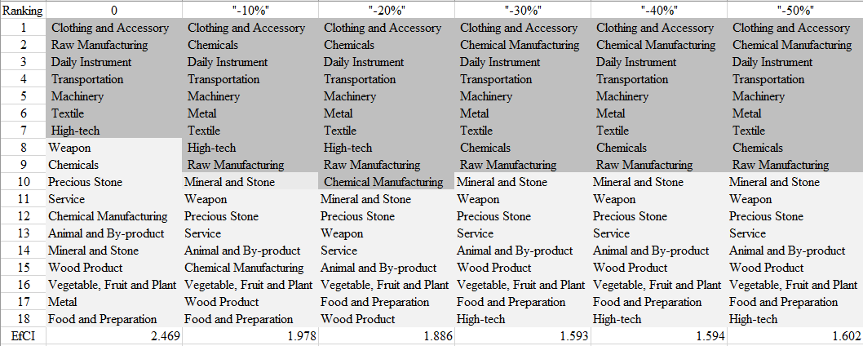
.

Table 9: Aggregated High-complexity Products 2014( Decremental Sensitivity)

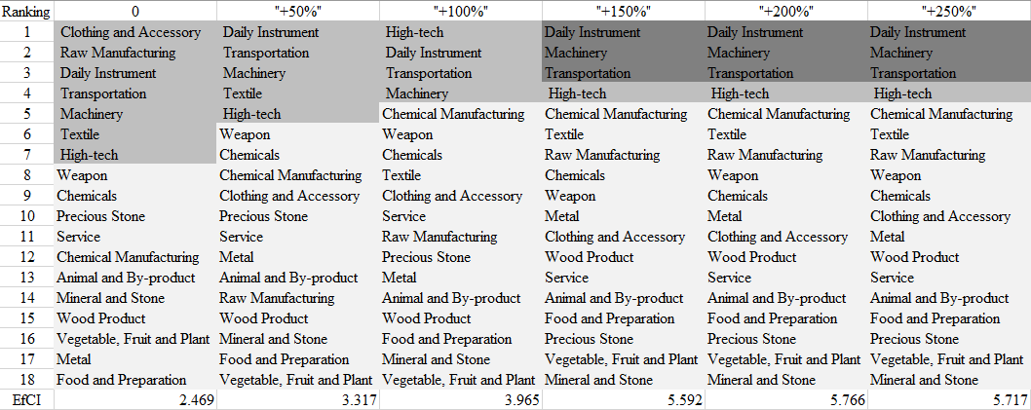

Table 10: Aggregated High-complexity Products 2014( Incremental Sensitivity)

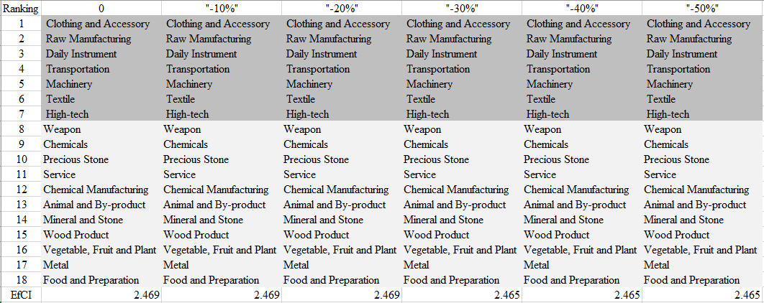

Table 11: Aggregated Food and Preparations 2014( Decremental Sensitivity)

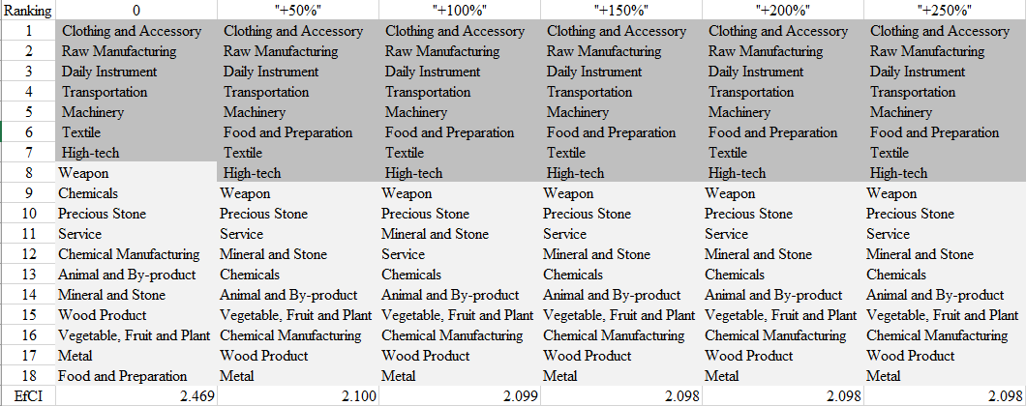

Table 12: Aggregated Food and Preparations 2014( Incremental Sensitivity)

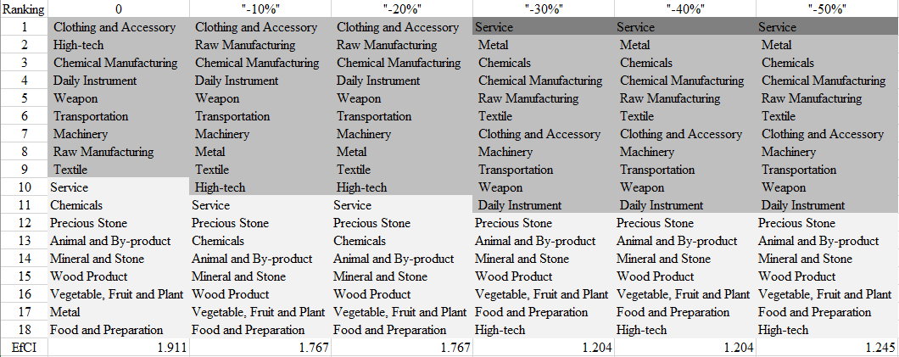

Table 13: Aggregated High-complexity Products 2009 ( Decremental Sensitivity)

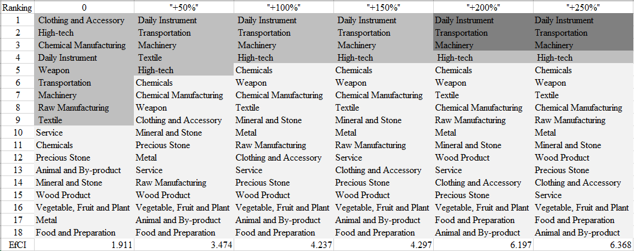

Table 14: Aggregated High-complexity Products 2009 ( Incremental Sensitivity)

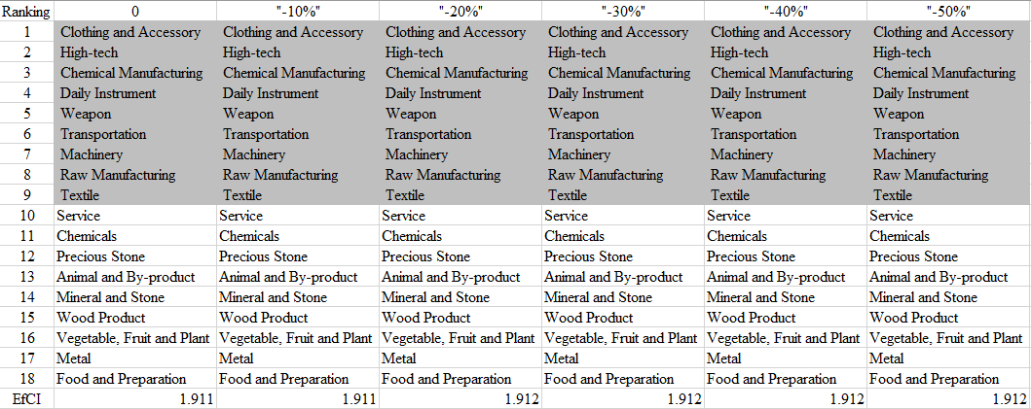

Table 15: Aggregated Food and Preparations 2009 ( Decremental Sensitivity)

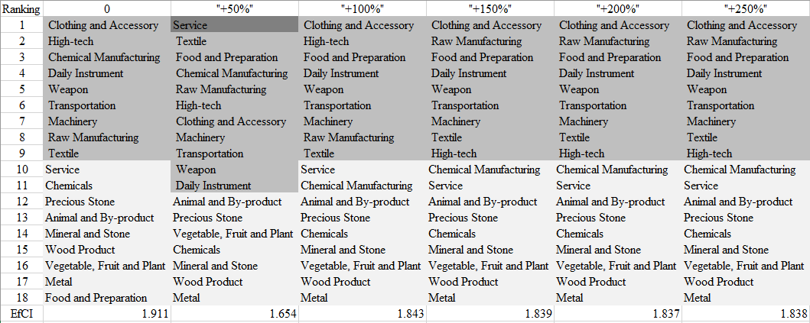

Table 16: Aggregated Food and Preparations 2009 ( Incremental Sensitivity)

The Contingency Plan aims to present a set of solutions with respect to upheavals in different industries. Instead of compensating for the declining production directly, the best strategy is to develop those incipiently profitable industries. In this manner, we can derive the contingency strategy for countries to deal with possible abrupt declines of crucial industries. In some cases, the SDV remains unchanged even when a zero-opportunity-gain industry declines to its 20% in terms of export. We can then conclude the industry is not indispensable to the country. As a clarification, the three consecutive N/As means that the country doesn’t even need to respond to a collapse in the industry. Countries tend to have distinct solutions to the up and down of the same industry.

4.3 Result and interpretation
The sensitivity analysis of U.S. ends up with the results below.

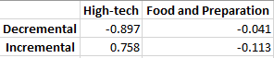

Table 17: Sensitivity Score of U.S. 2014

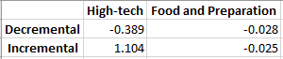

Table 18: Sensitivity Score of U.S. 2009

The U.S. has a sensitivity score vastly different from other developed or fast developing countries. It has a negative decremental sensitivity score for High-complexity Products, which indicates that U.S. is totally immune from High-complexity Products downturns, if any. Besides that, it, like other developed or fast developing countries is not sensitive to Food and Preparations Industry.
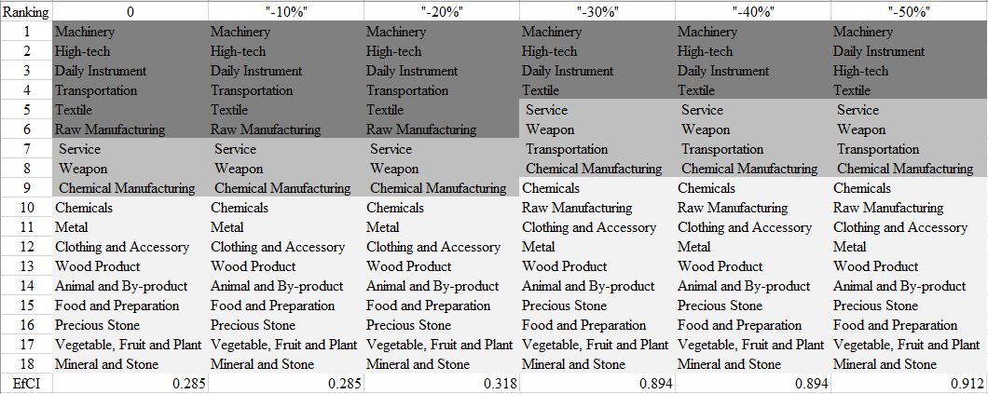

Table 19: U.S. High Tech 2014 (Decreasing Sensitivity)

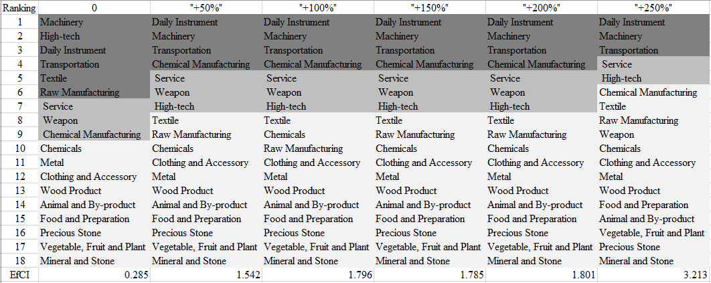

Table 20: U.S. High Tech 2014 (Incremental Sensitivity)

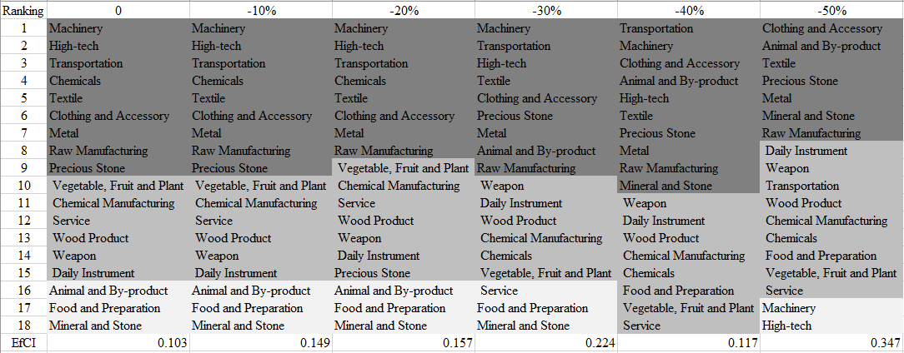

Table 21: U.S. High Tech 2009 (Decreasing Sensitivity)

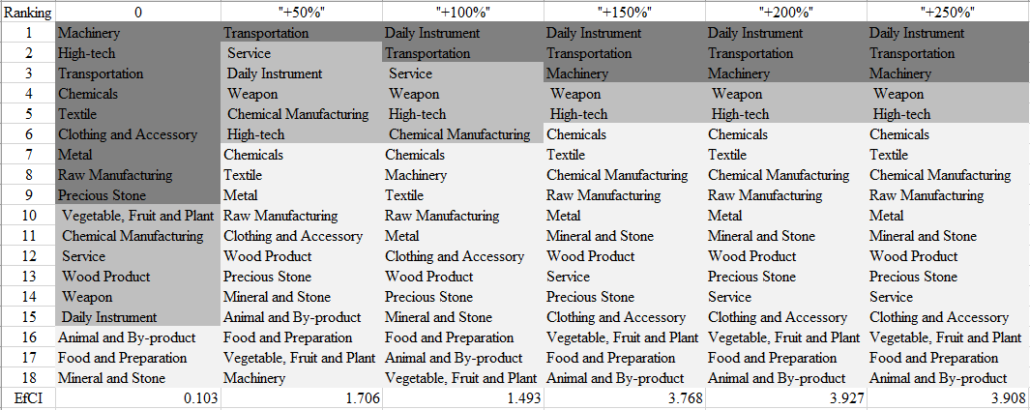

Table 22: U.S. High Tech 2009 (Incremental Sensitivity)

As shown in Table 19---Table 22 above, the economy of U.S. is in a much more sensitive and fragile state in 2009, compared to 2014. Table 21 and 22 show that U.S. is obviously suffering from a crisis, in fact The Global Financial Crisis, in 2009. Even though, a downturn in High-complexity Products wouldn’t have deteriorated the crisis, a breakthrough would make U.S. recover fast. An increase of High-complexity Products production in 2009 would almost wipe out all positive -opportunity-gain industries and then stimulate Machinery and Construction, Daily Instruments and Transportation industries for further development. Surprisingly, based on the ECI framework, U.S. is not performing well as we expect.

Decreasing export of each industry in U.S.’s current production space by 60% respectively, we derive the contingency strategy shown below in Table 14.

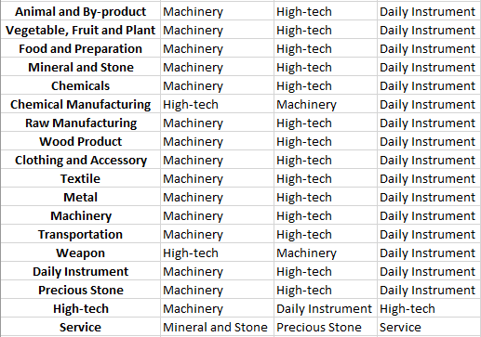

Table 20: Contingency Table of U.S. during Industry Strikes 2014

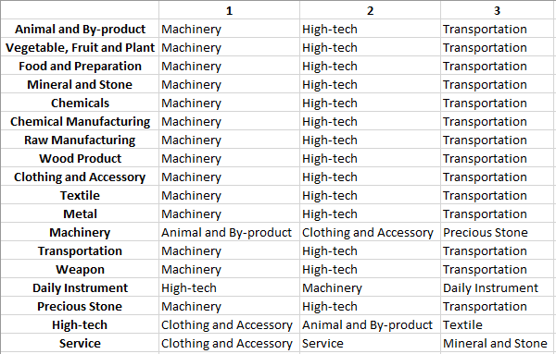

Table 21: Contingency Table of U.S. during Industry Strikes 2009

Interestingly, Machinery and Construction, High-complexity Products and Transportation can relieve crisis in all other industries. If these three industrial related industries run into problems, Clothing and Accessories is the best solution.

5. Macro-level Predictions

5.1 Structural Optimality Index
Indeed, such choice of prioritization has proven to be a significant factor in deciding the economic outcomes of countries. In order to quantitatively evaluate how effective our developmental strategies are and how deviations from the suggested developmental path will lead to non-optimal growth results, we define the measure – Structural Optimality Index (SOI) – on a country level as the R-Square obtained from regressing the country’s realized industry development over the suggested development strategy. Both strategies are quantified in nature, with the realized industry development represented by export increase in major industry groups and the suggested development strategy represented by the opportunity gains of developing the corresponding industry groups as calculated in previous sections. The R-square from the regression thus provides us with a concrete measure of how the development path adopted by the country has fitted with/differed from our suggestion.

After obtaining this measure for all countries in our database, we further regress countries’ five-year economic growth, which is defined as the net increase in GDP (USD), over their SOI. Figure 6 illustrates the regression output, which shows a strong positive correlation between countries’ SOI and their five-year GDP growth, significant at the 1% level and achieving an adjusted R² of 11.9%. In other words, the more a country develops as suggested by calculations on a complexity level, the better economic outcomes it achieves.

Statistics | Value
Multiple R | 0.355
R-Square | 0.126
Adjusted R² | 0.119
Variable | Value
Coefficient | 1.249*10¹²
t-stat | 4.061
P-value | 0.000(***)


Figure 6: Regression of Five-year GDP Growth over SOI

5.2 SOI of U.S. and Its Implications
U.S., for instance, has a moderate level of structural optimality as compared with its emerging peers. As the regression in Figure 7 suggests (the orange curve represents export increase and the blue curve stands for opportunity gain of the corresponding industry), U.S. demonstrates an average level of correlation with the suggested developmental path, having an adjusted R-square of around 28.7%. U.S. ranks the 15th place among all countries in terms of SOI and has made an average rate of economic progress among its emerging peers from 2009 to 2014 with an annual GDP growth rate of 3.9%, which is consistent with the regression result in Figure 6. This is in direct contrast to emerging economies such as China, where there is high SOI of around 82.8% and a corresponding GDP growth of 5.39 billion USD, making it one of the fastest developing economies during the period. In sum, U.S.’s stable economic progress from 2009 to 2014 can be at least partially explained by a development strategy that demonstrates a considerable but not perfect level of matches with our suggested developmental path. In specific, U.S. invested heavily in the Services and Utilities industry, while it should have focused more on moderately complex industry groups such as chemical manufacturing.


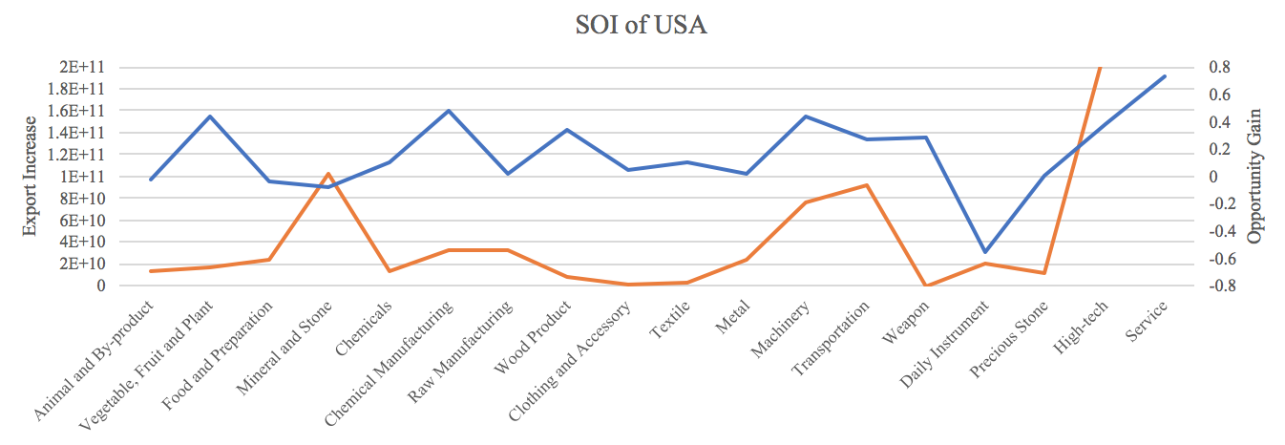

Figure 7: SOI of U.S. (2009-2014)

6. Concluding Remarks

In conclusion, U.S. has demonstrated a moderate level of economic growth in terms of annual GDP increase during the period from 2009 to 2014, concurrent with a decrease in economic complexity as compared with other major developed economies.

The lack of progress during the period, we believe, can be partially explained through analysis of the economic and product complexity structure of U.S. on the industry group level. The product classification system we adopt allows us to measure the realized industry development for various industry groups and to observe that U.S. consistently relied on developing Services and Utilities, food, Textiles and clothing industries during the period, while its developed counterparts and emerging economies around the globe have adopted much more complex and progressive paths.

Based on our analysis of the opportunity gain and a sensitivity analysis of major industry groups, U.S. can further its gains by prioritizing Machinery and Construction, transportation, and those related to High-complexity Products industry groups. We further note that U.S. has a slightly mismatched development strategy that indicates a moderate level of structural optimality on the complexity level, having an adjusted R-square of around 28.7%. Since a significant positive correlation exists between five-year GDP growth and the structural optimality index of an economy as we define and calculate, U.S. indeed has a suboptimal growth experience as compared with fast-growing economies both on a regional scale and on a global scale, and has the potential to further its economic gains through industrial structure optimization as suggested in the paper.

References

Hausmann, R., Hidalgo, C., Bustos, S., Coscia, M., Chung, S., Jimenez, J., Simoes, A. and Yıldırım, M. (2007). The Atlas of Economic Complexity. [online] Atlas.cid.harvard.edu. Available at: http://atlas.cid.harvard.edu/.

Balassa, B., “The Purchasing Power Parity Doctrine - A Reapprais- al,” Journal of Political Economy 72, 584-596 (1964).

Feenstra, R.; Lipsey, R.; Deng, H.; Ma, A. & Mo, H. “World Trade Flows: 1962-2000” NBER working paper 11040. National Bureau of Economic Research, Cambridge MA (2005).

United Nations Commodity Trade Statistics Database (http://comtrade.un.org/db/), accessed in August 2019.

The World Economic Forum, “The global competitiveness report,” (various years).

Barro, R. & Lee, J-W. “A New Data Set of Educational Attainment in the World, 1950-2010,” NBER Working Paper No. 1590 (2010).

Kaufmann, D. & Kraay, A. “Governance Indicators: Where Are We, Where Should We Be Going?” Policy Research Working Paper 4370. Washington, DC: World Bank (2008).

Hanushek, E.A. & Woessmann, L. “The Role of Cognitive Skills in Economic Development,” Journal of Economic Literature 46(3), 607- 668 (2008).

